**Q1** **Write a SQL query to find out how many students are from each city. The output should list each city along with the number of students residing in that city.**

**Query –**

SELECT city, COUNT(*) AS number_of_students FROM student GROUP BY city;

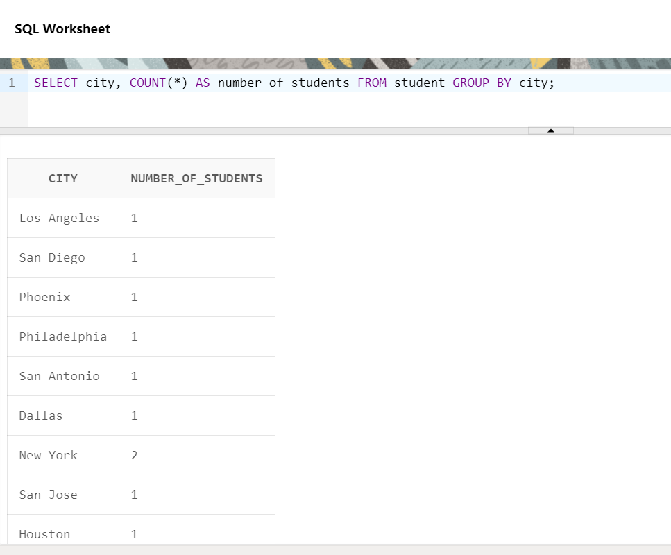**OUTPUT**

**Q2. Write a SQL query that provides the following information from the student table:**

1. **The total number of students.**
2. **The highest roll number among students.**
3. **The lowest roll number among students.**
4. **The average roll number of students.**
5. **The sum of all roll numbers.**
6. **The number of students in each city.**

**Query-**

1. SELECT COUNT(*) AS total_students FROM student;
2. SELECT MAX(roll_no) AS highest_roll_no FROM student;
3. SELECT MIN(roll_no) AS lowest_roll_no FROM student;
4. SELECT AVG(roll_no) AS average_roll_no FROM student;
5. SELECT SUM(roll_no) AS total_roll_numbers FROM student;
6. SELECT city, COUNT(*) AS number_of_students FROM student GROUP BY city;

**OUPUT**

